**Output:**

**1)Home Page**

**option: Javascript, Asp.Net and C# (C Sharp))**

1

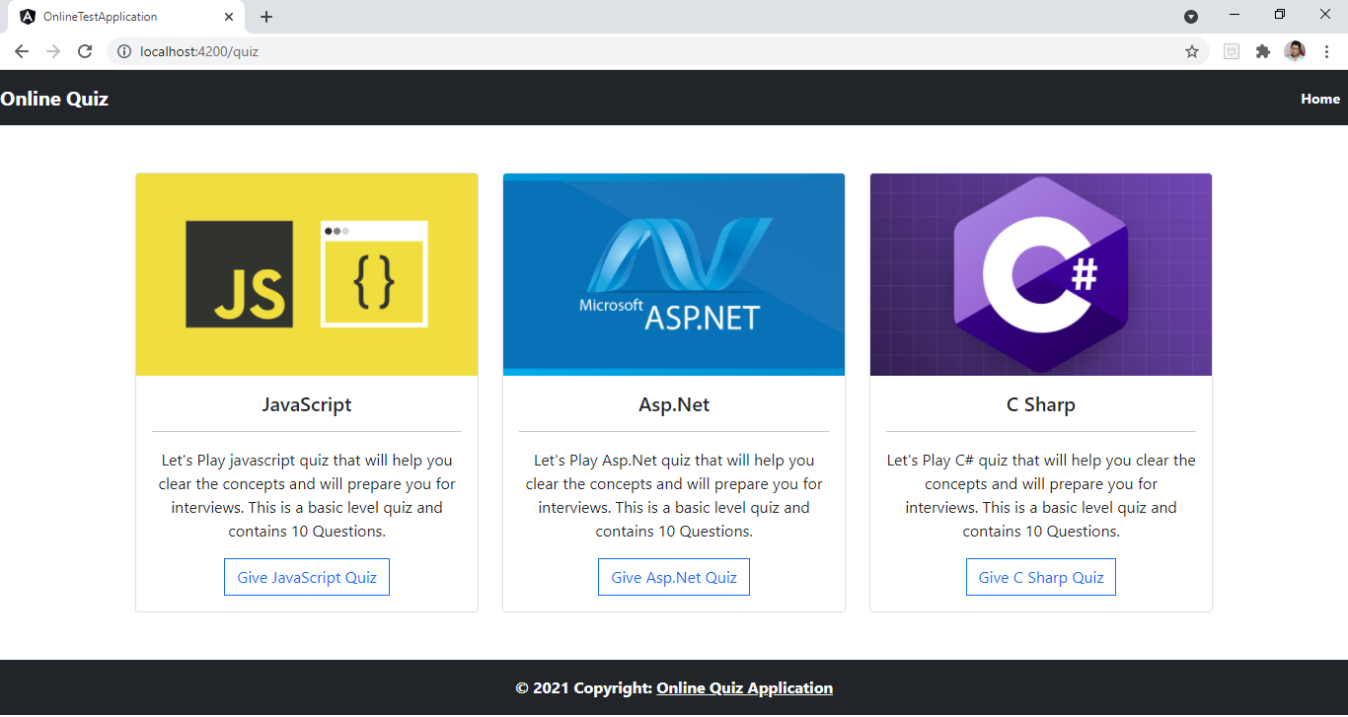

2)Javascript Quiz:

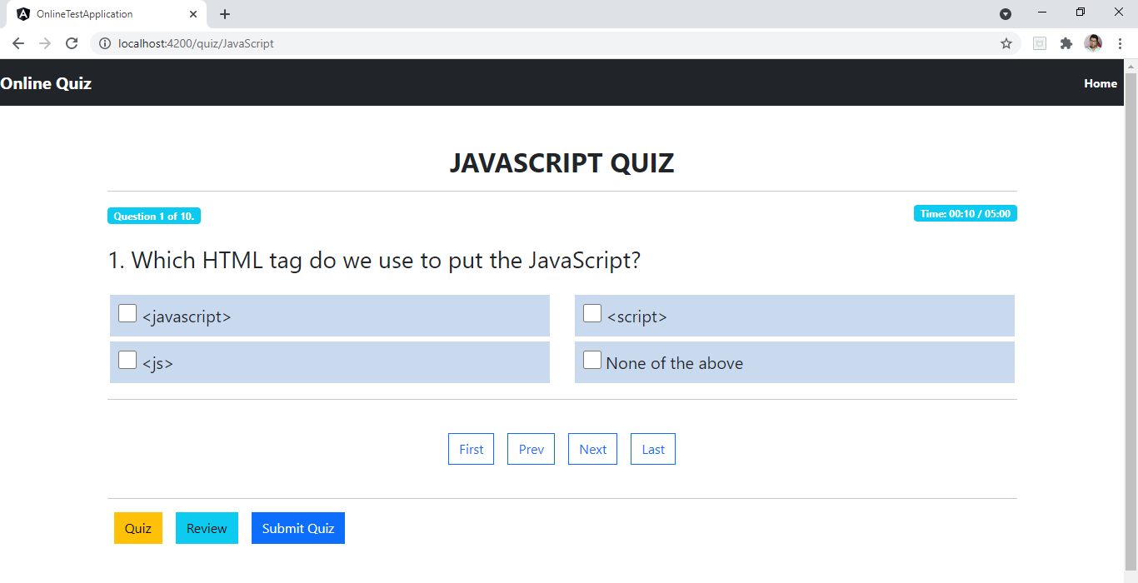

**3)Navigation keys: first,prev,Next,last**

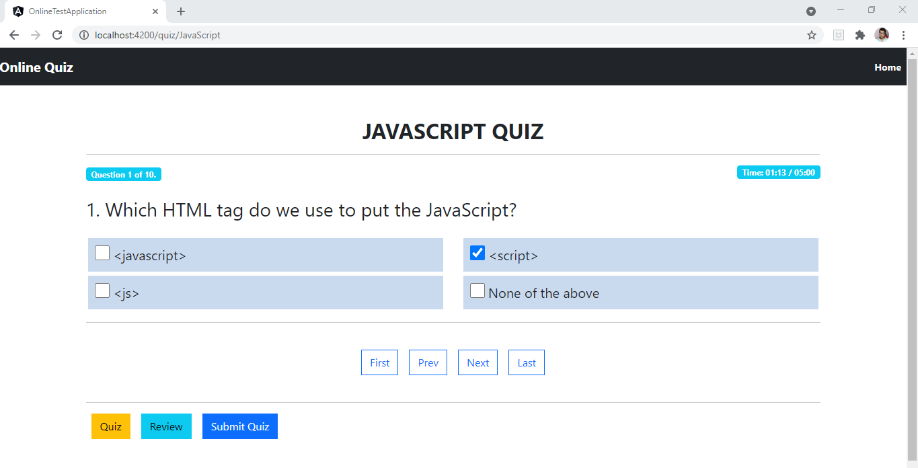

**User can select an option for the question and move to next question by clicking next navigation button**

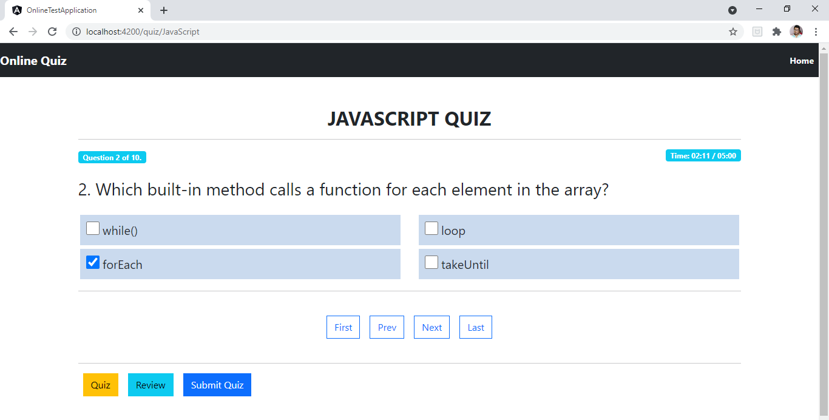

**Similarly, User can Answer all the questions asked**

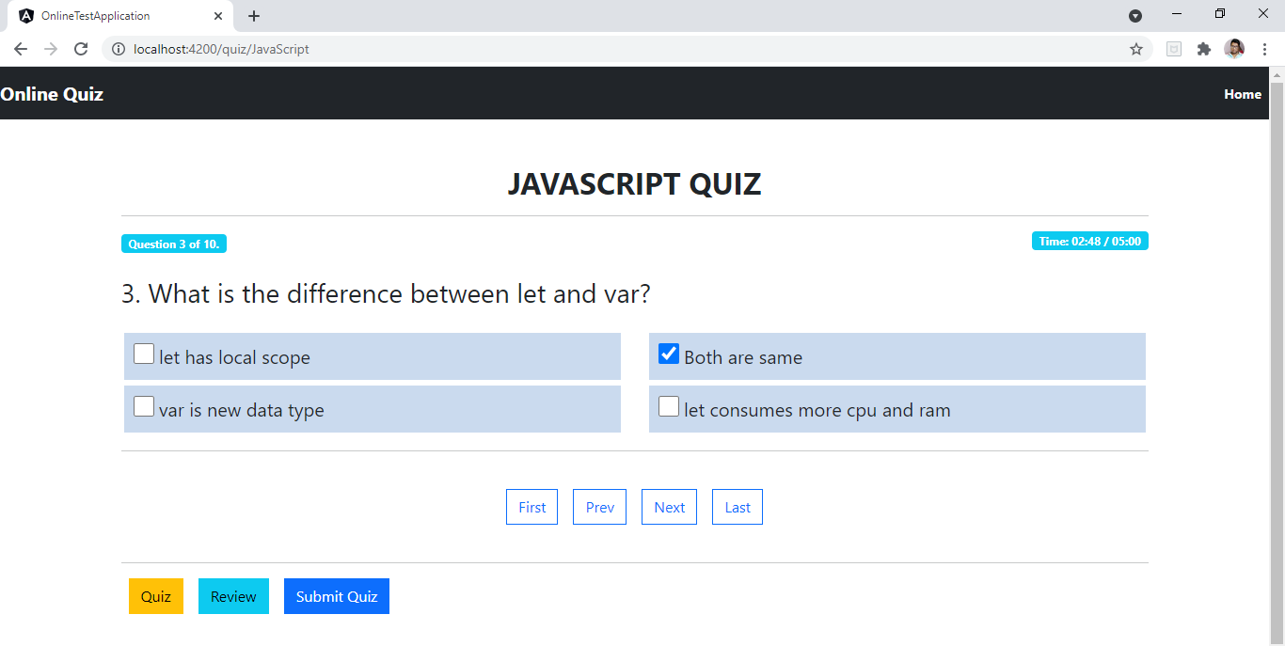

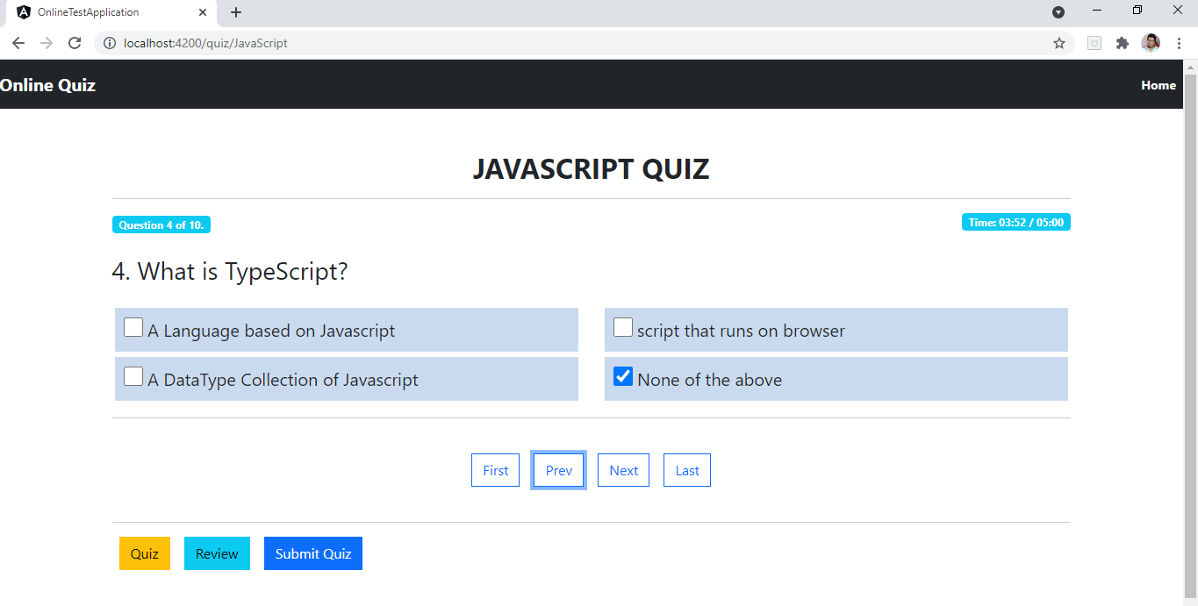

**User can also navigate to last or First question directly from First and Last Nav Links**

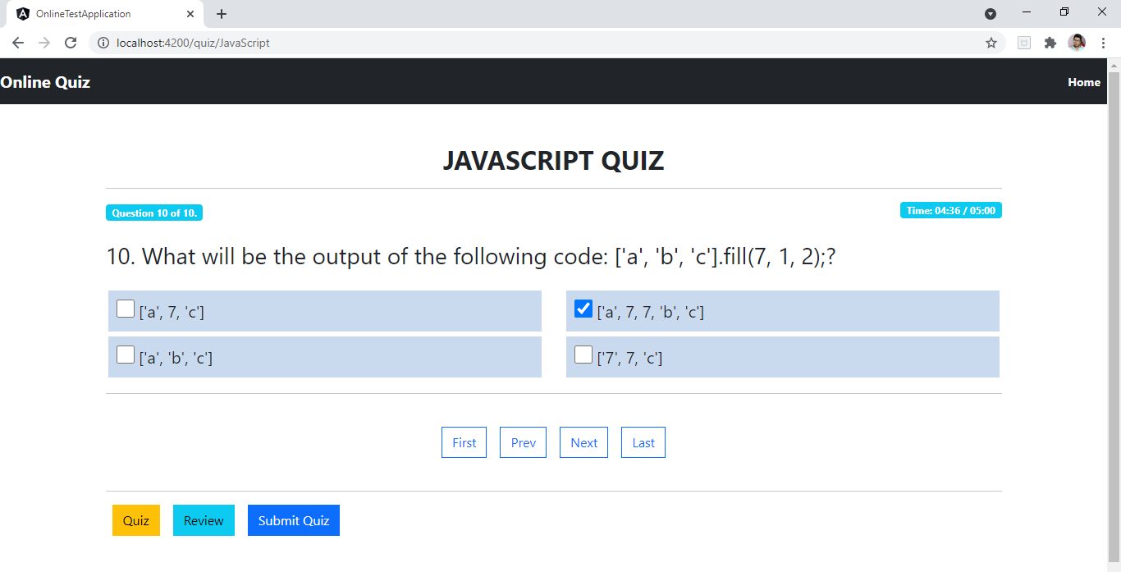

**User can Review All the Answered and Not Answered Questions by Clicking on Review Nav Link.**

**Also user can go to specific question to answer by clicking on any of the Question Blocks.**

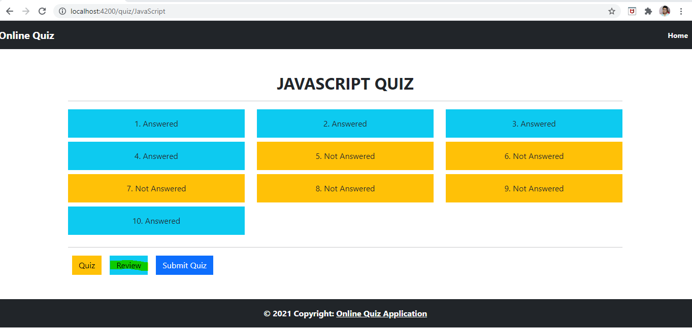

**User wanted to answer the 5th Not Answered Question:**

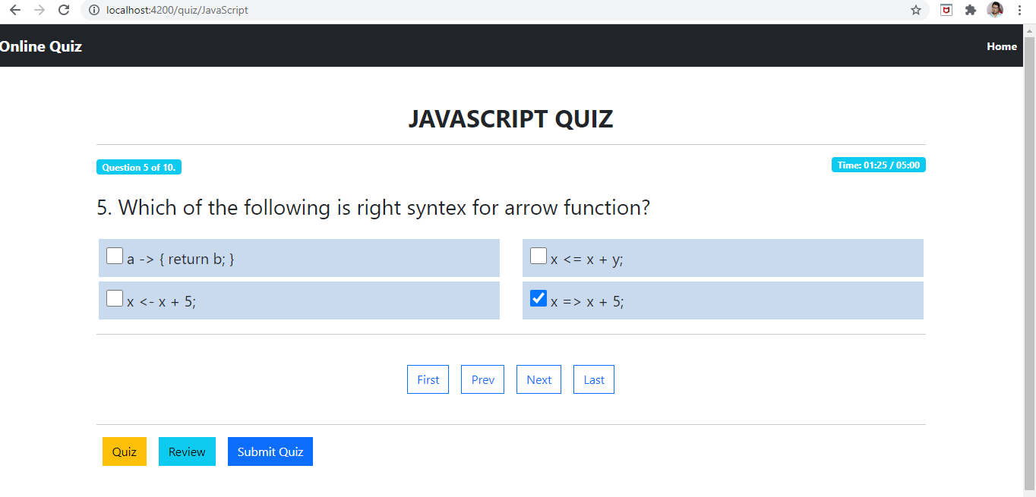

**Now we can see the 5th Question is marked as Answered:**

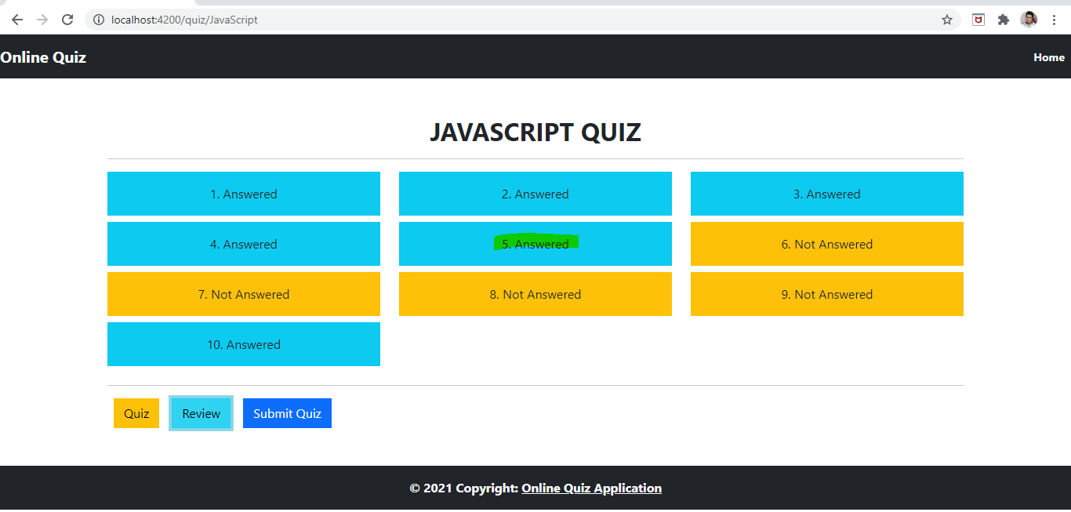

**When The user clicks on Submit button, they can see their result along with Questions and Options they have selected:**

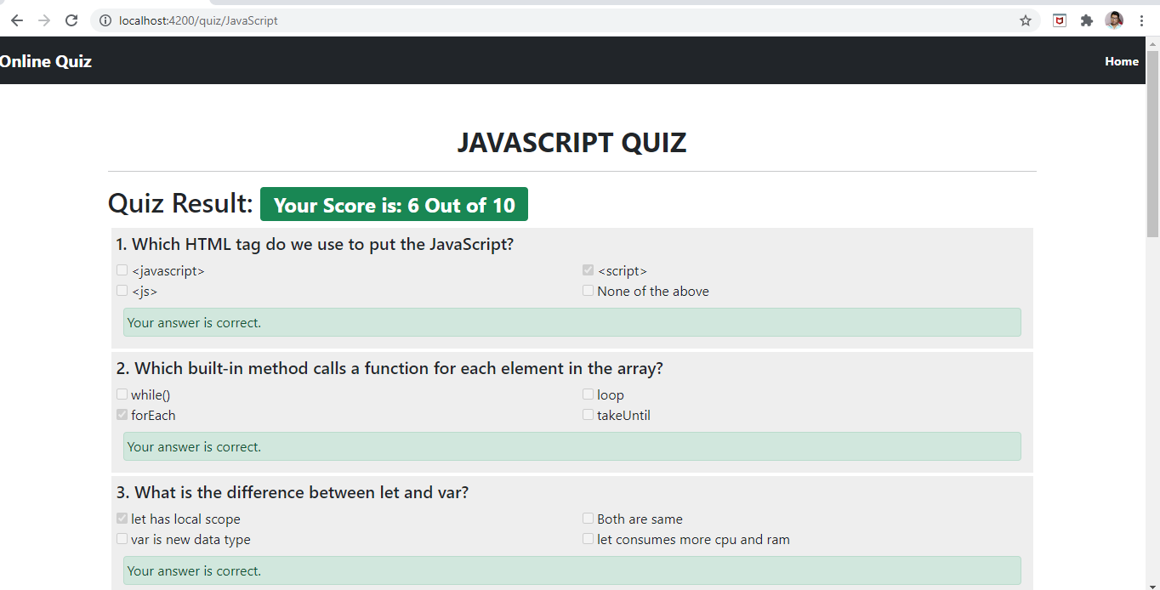

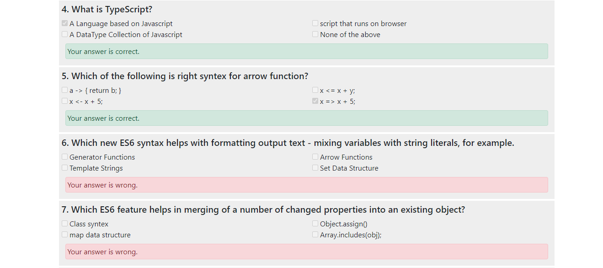

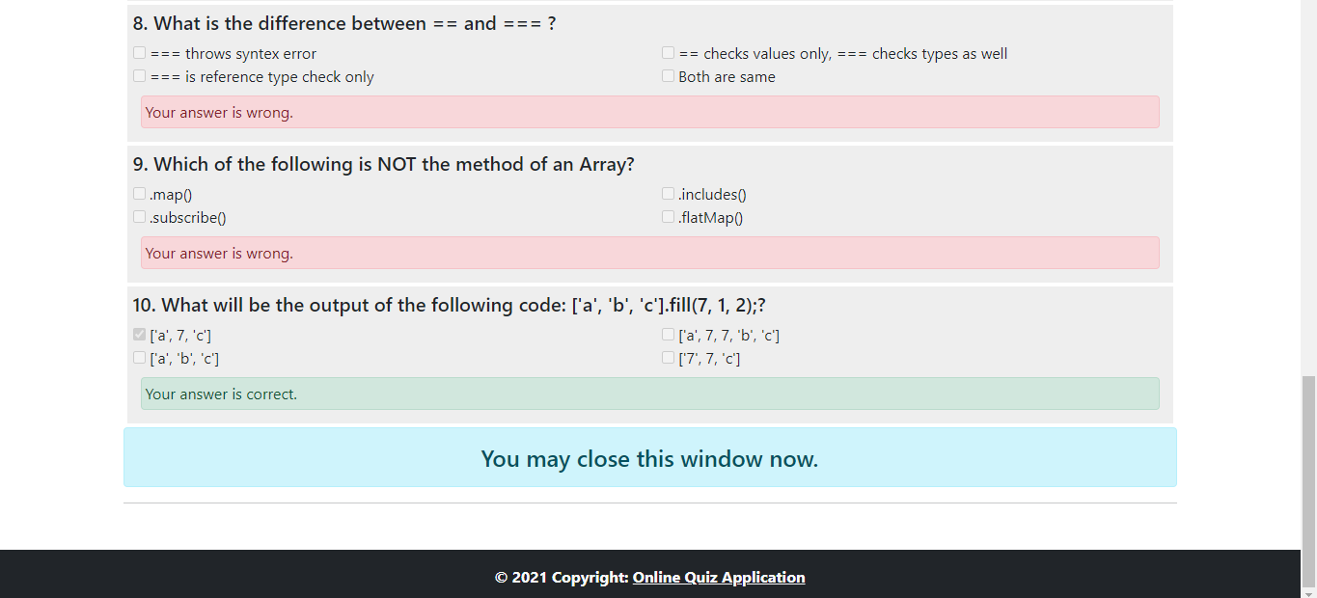

1. **User Selects to give Asp.Net Quiz**

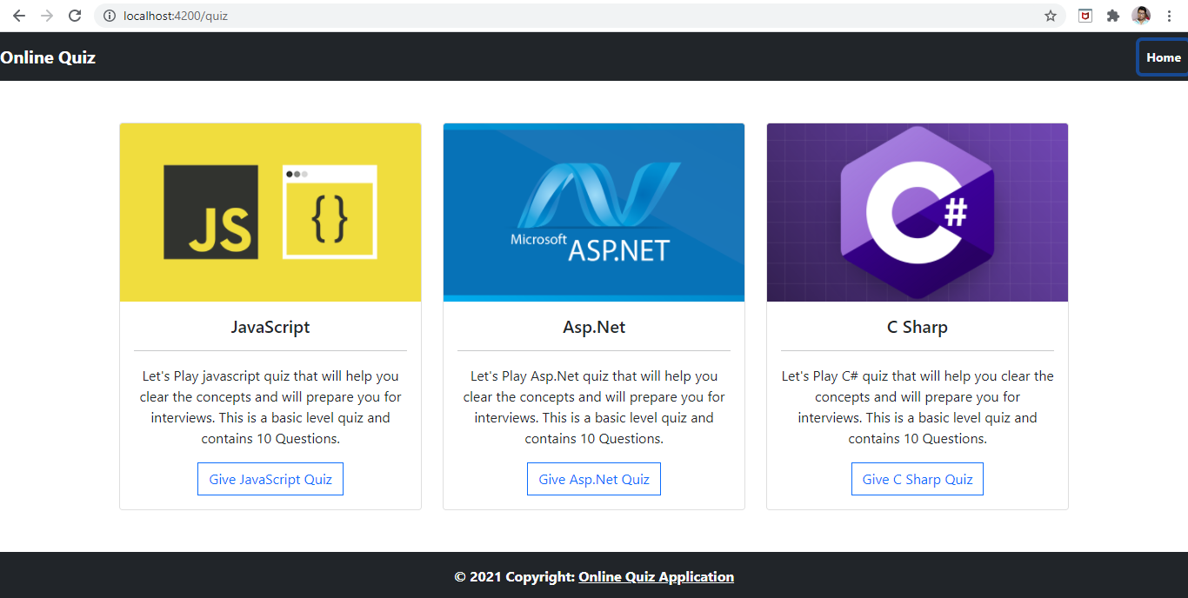

**When User Selects Asp.Net Quiz, they are redirected to Asp.Net quiz page where they can see all the questions with their options rendered from JSON file.**

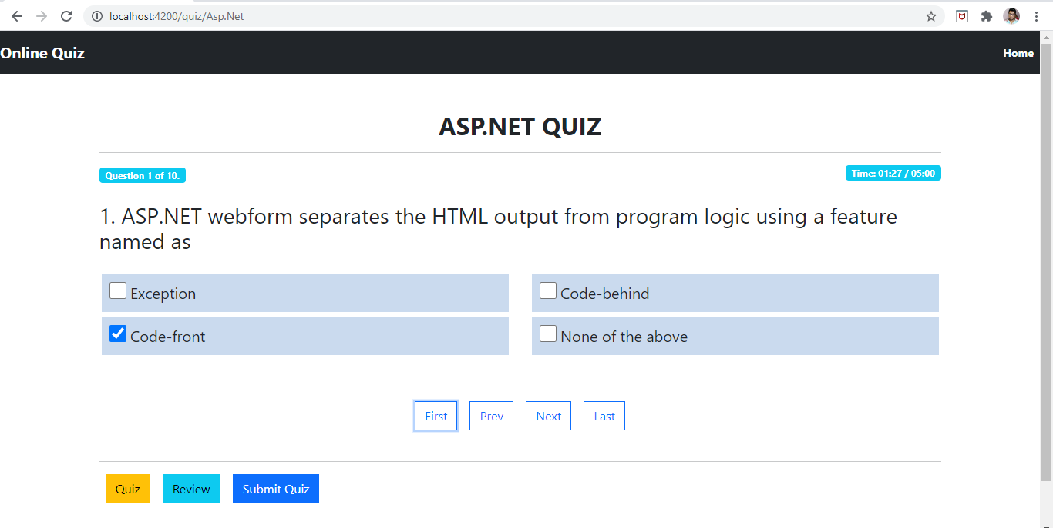

**User can select an option for the question and move to next question by clicking next navigation button**

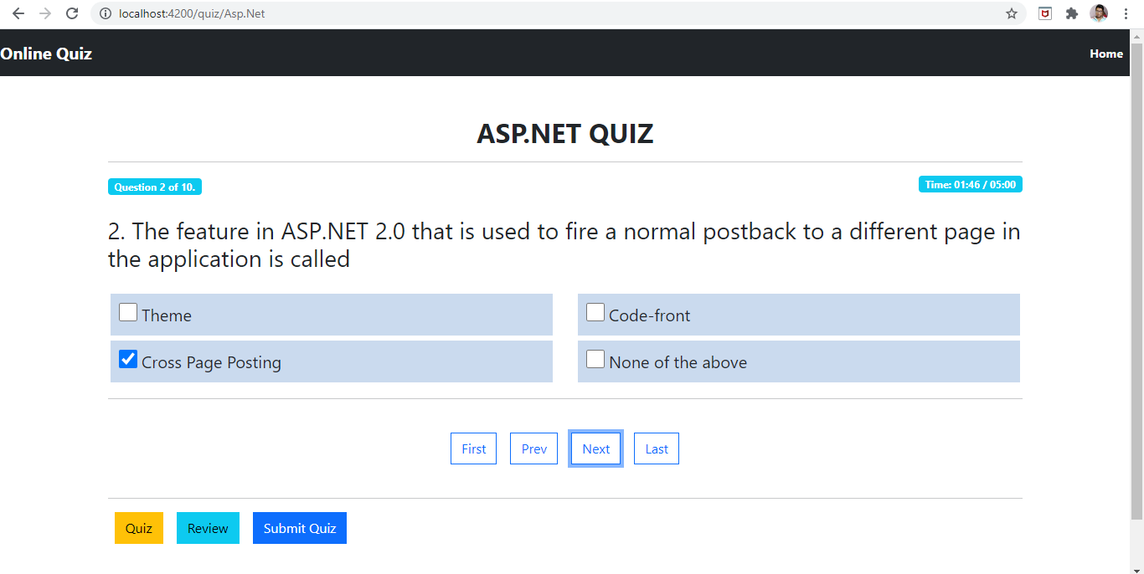

**Similarly, User can Answer all the questions asked**

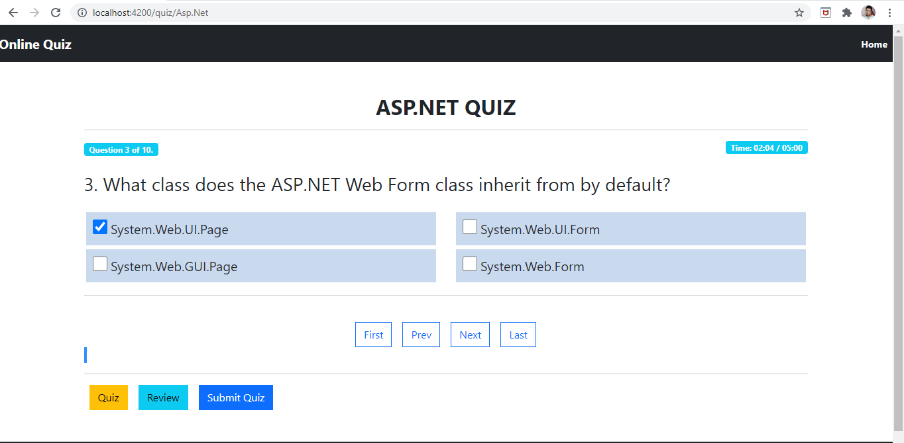

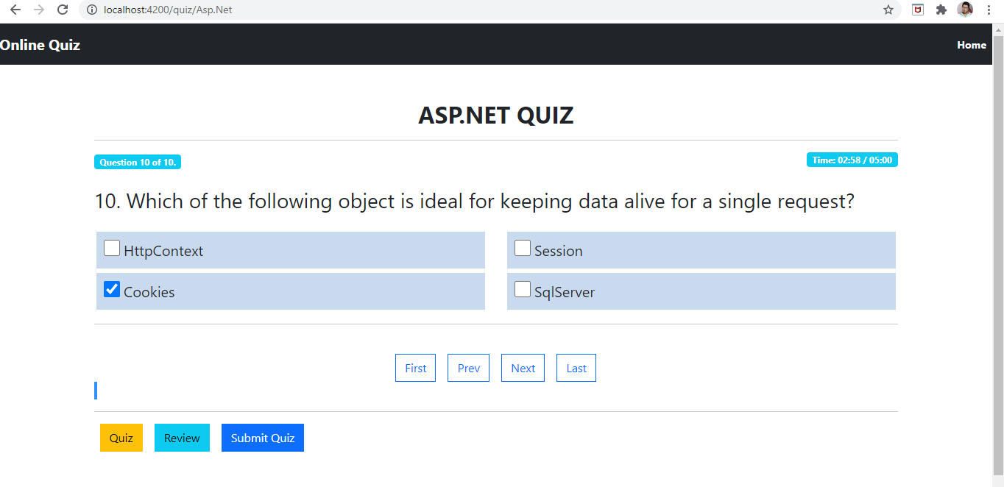

**Similarly, User can Answer all the questions asked**

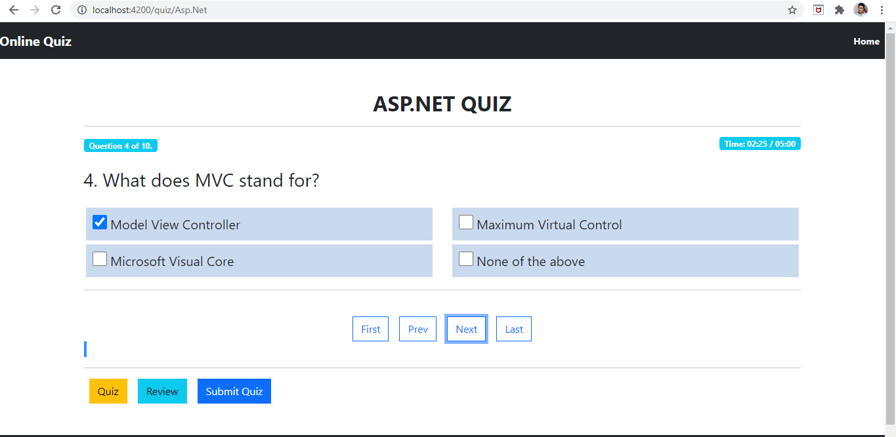

**User can also navigate to last or First question directly from First and Last Nav Links**



**User can Review All the Answered and Not Answered Questions by Clicking on Review Nav Link.**

**Also user can go to specific question to answer by clicking on any of the Question Blocks.**

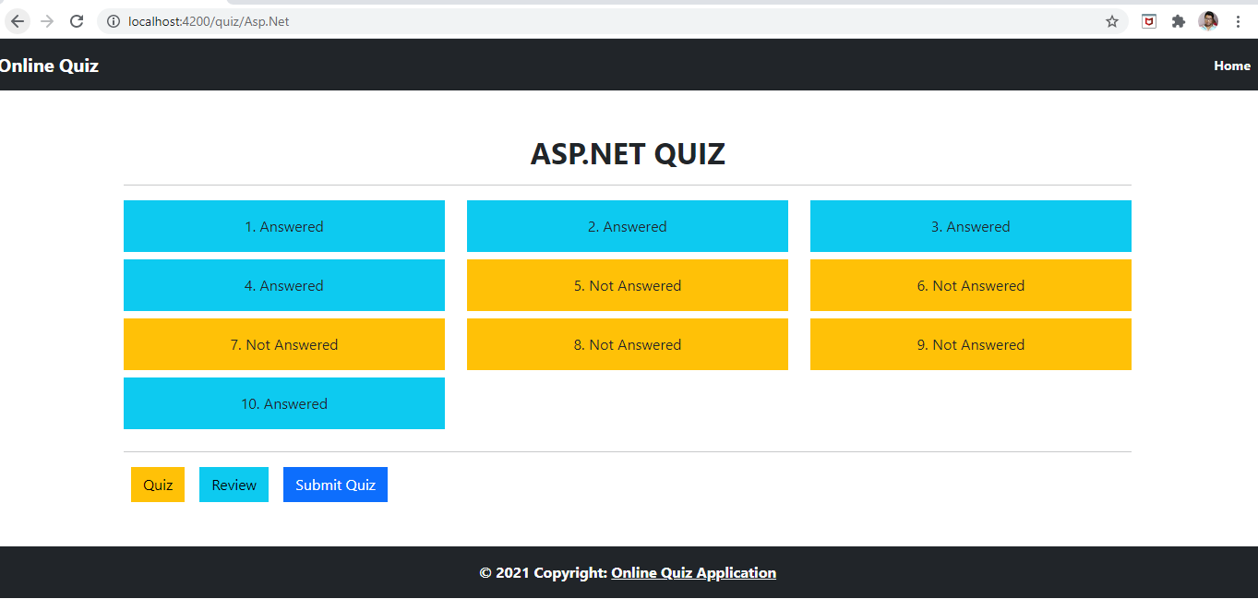

**User wanted to answer the 9th Not Answered Question:**

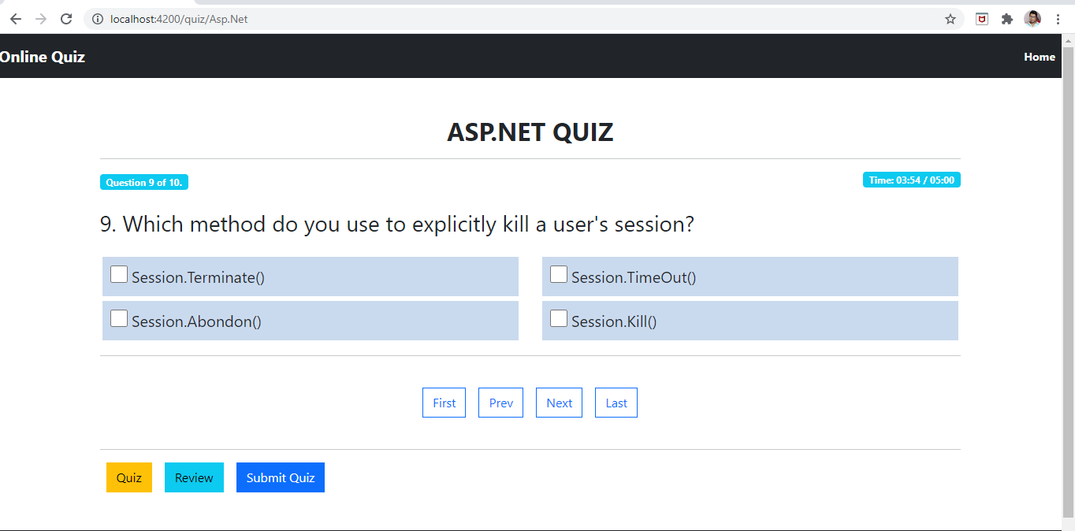

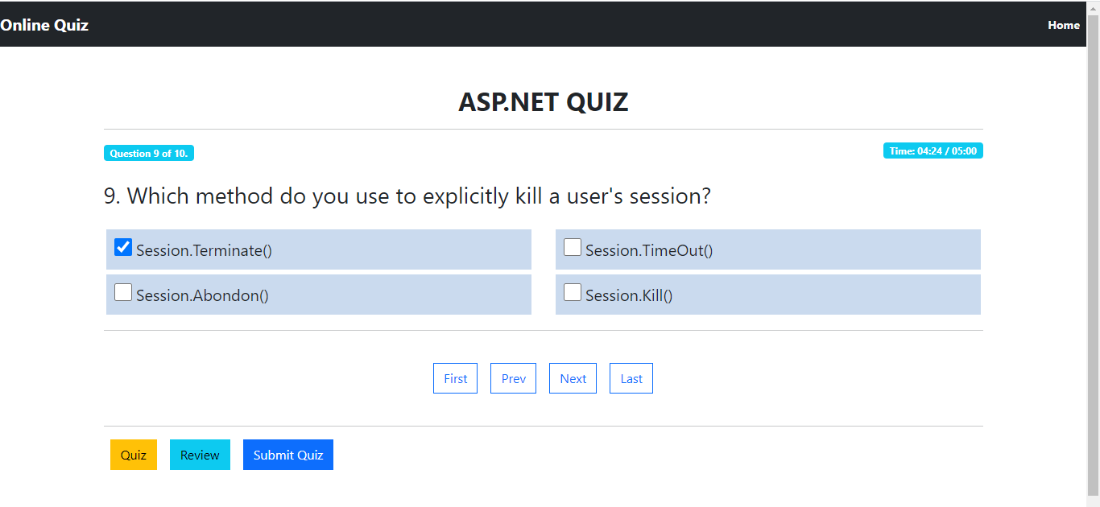

**9th  Question is Answered Now:**

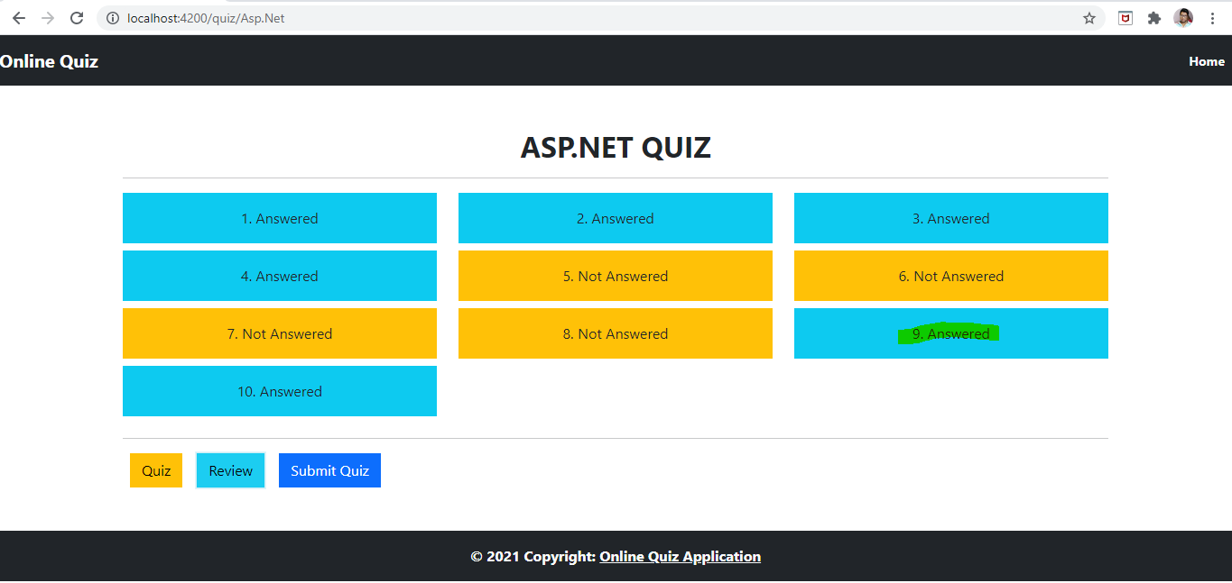

**When The user clicks on Submit button, they can see their result along with Questions and Options they have selected:**

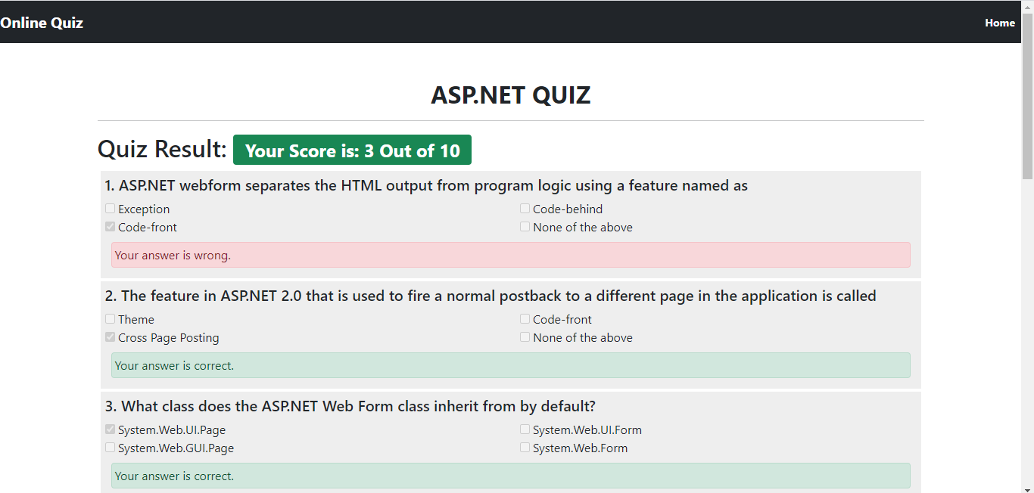

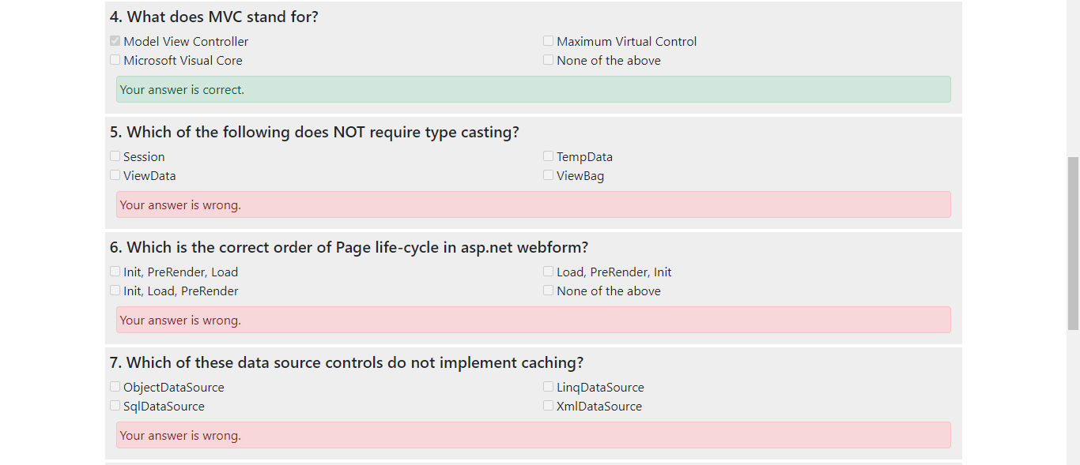

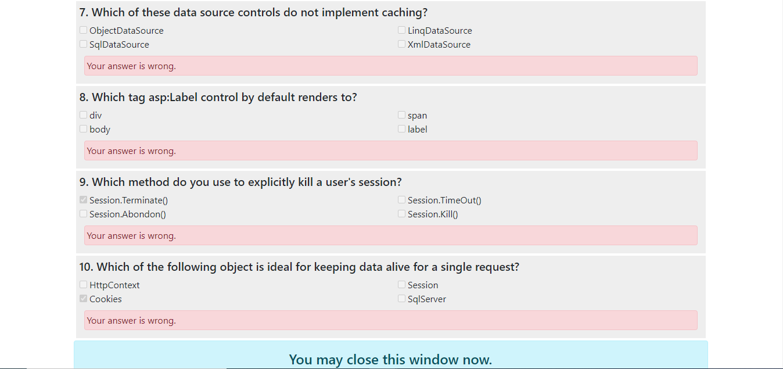

1. **User Selects to give C Sharp Quiz**



